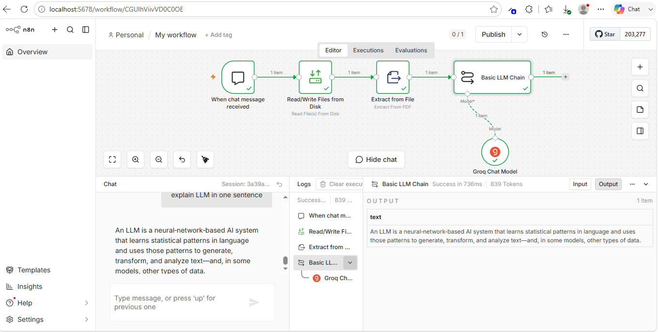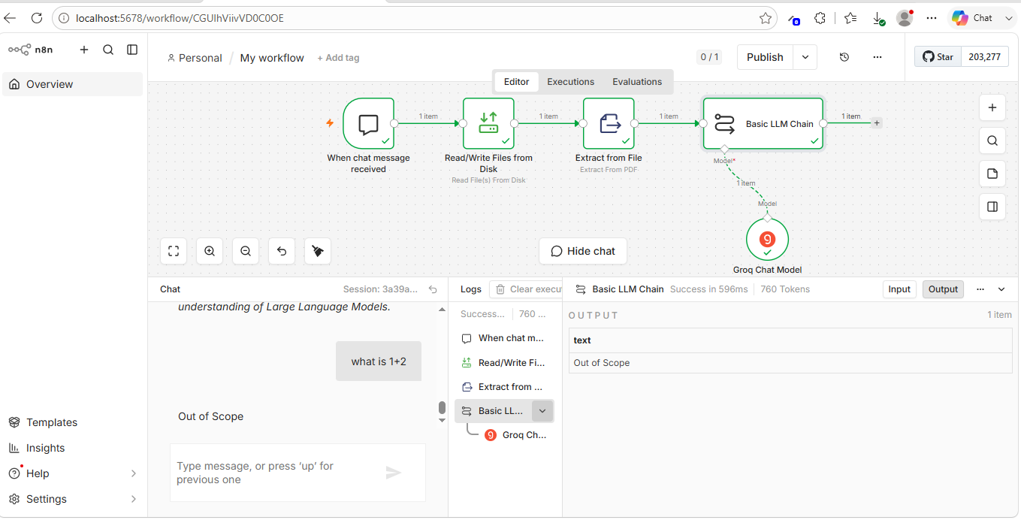
{
"name": "Q&A Agent",
"nodes": [
{
"parameters": {
"options": {}
},
"type": "@n8n/n8n-nodes-langchain.chatTrigger",
"typeVersion": 1.4,
"position": [
-560,
16
],
"id": "dd0c8f1c-70d4-48dc-81f1-7d8fcce5821a",
"name": "When chat message received",
"webhookId": "01ed856f-4194-47ea-bf49-c6449b24e51d"
},
{
"parameters": {
"promptType": "define",
"text": "={{ $json.text }}",
"messages": {
"messageValues": [
{
"message": "=For this given Input java code :{{ $('When chat message received').item.json.chatInput }} follow these;\n\nInstuctions:\n\nYou need to answer for the questions asked by user only from the referred document\nand do not answer if the question is irrelevant from the document content \n\nC – Context\n\nThe input Java code belongs to a production-grade software project (could be backend automation, web app, or API service).\nAssume that this code will be part of a shared repository reviewed by multiple developers, so it must comply with clean code, maintainability, and security standards.\nYou are reviewing this code as part of a formal pull request (PR) process.\n\nThe input from the chat node is a question and find answers only from the document attached and extracted, do not assume anything.\nIf you don't find the answer for the question from document, give resposne as 'Out of Scope'\n\n\nImprovement Areas:\nIf you don't find the answer for the question from document, give resposne as 'Out of Scope'\n\nSummary:\n\n\nP – Persona\n\nAct like a Question and Answer Agent and answer for the questions by finding answers from document attached"
}
]
},
"batching": {}
},
"type": "@n8n/n8n-nodes-langchain.chainLlm",
"typeVersion": 1.9,
"position": [
112,
16
],
"id": "45a9b82c-da35-4d29-a9f2-76255e03647b",
"name": "Basic LLM Chain"
},
{
"parameters": {
"model": "openai/gpt-oss-120b",
"options": {}
},
"type": "@n8n/n8n-nodes-langchain.lmChatGroq",
"typeVersion": 1,
"position": [
192,
240
],
"id": "6923dfc3-c6d2-465b-a75f-cd5574d68c31",
"name": "Groq Chat Model",
"credentials": {
"groqApi": {
"id": "DcpUWaz62qbAQXWa",
"name": "Groq account"
}
}
},
{
"parameters": {
"fileSelector": "C:\\Users\\Welcome\\.n8n-files\\LLM_One_Page_Summary.pdf",
"options": {}
},
"type": "n8n-nodes-base.readWriteFile",
"typeVersion": 1.1,
"position": [
-336,
16
],
"id": "a8c95ce2-376e-430f-a1a0-bf854d4ec2df",
"name": "Read/Write Files from Disk"
},
{
"parameters": {
"operation": "pdf",
"options": {}
},
"type": "n8n-nodes-base.extractFromFile",
"typeVersion": 1.1,
"position": [
-112,
16
],
"id": "9dbb4a48-c84d-4709-9fb1-4a6b79ea814e",
"name": "Extract from File"
}
],
"pinData": {},
"connections": {
"When chat message received": {
"main": [
[
{
"node": "Read/Write Files from Disk",
"type": "main",
"index": 0
}
]
]
},
"Groq Chat Model": {
"ai_languageModel": [
[
{
"node": "Basic LLM Chain",
"type": "ai_languageModel",
"index": 0
}
]
]
},
"Read/Write Files from Disk": {
"main": [
[
{
"node": "Extract from File",
"type": "main",
"index": 0
}
]
]
},
"Extract from File": {
"main": [
[
{
"node": "Basic LLM Chain",
"type": "main",
"index": 0
}
]
]
}
},
"active": false,
"settings": {
"executionOrder": "v1",
"binaryMode": "separate",
"availableInMCP": false
},
"versionId": "fe178be3-d158-4483-9408-b68f4437c553",
"meta": {
"templateCredsSetupCompleted": true,
"instanceId": "29696833747dc5841f04be72aa42df84f50a6db352a897de12f8e5271522e5ed"
},
"nodeGroups": [],
"id": "CGUlhViivVD0C0OE",
"tags": []
}

